**Dhananjay Gokhale**

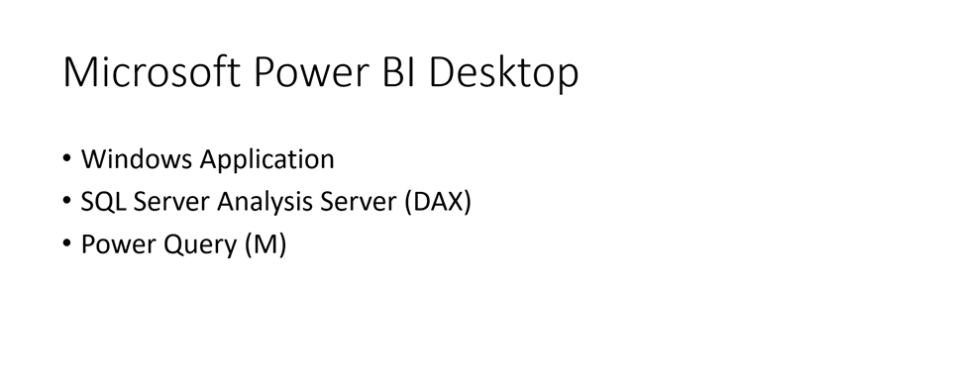

M -Mesap language

Power Query-ETL

ADL

DAX – Transformation

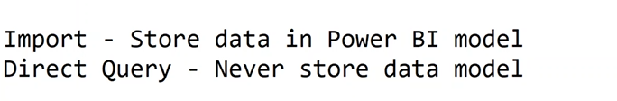

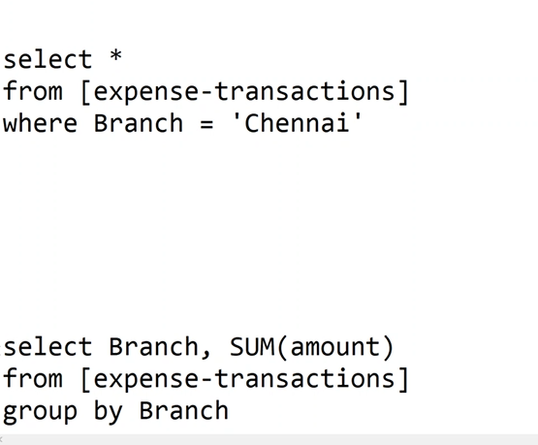

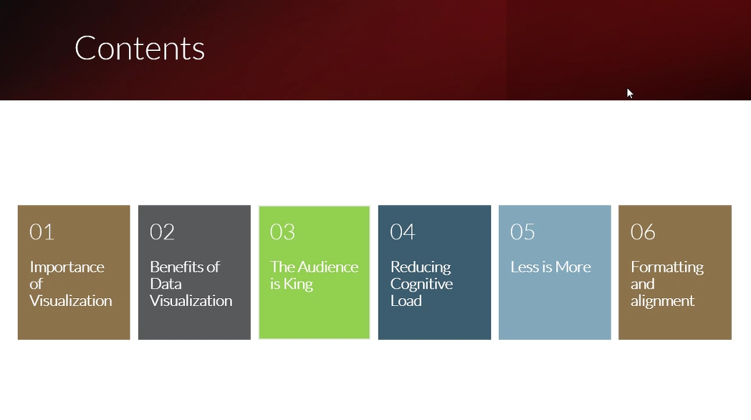

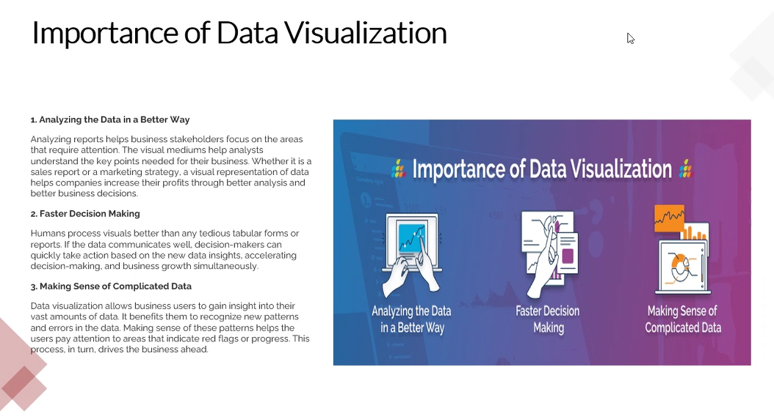

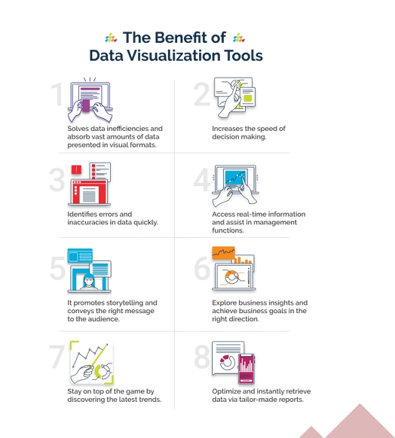

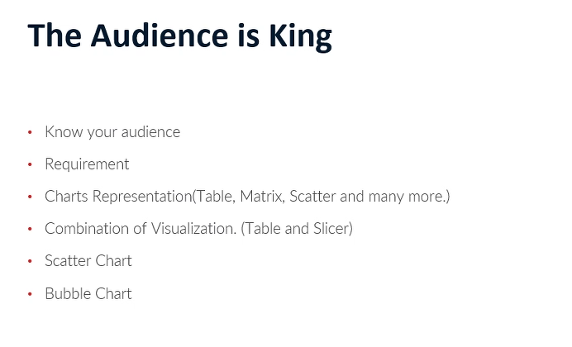

Day 2:

1. Use of viz.  
   1. Table  
   2. Matrix  
   3. Cards  
   4. Multi card  
   5. Bar chart  
   6. line chart  
   7. Pie chart  
   8. Tree diagram  
   9. Others
2. 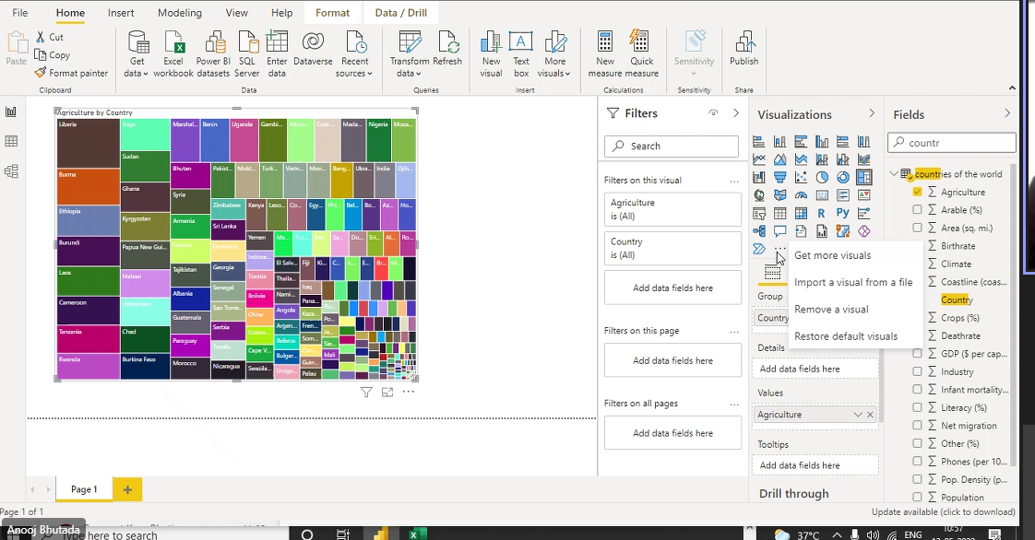

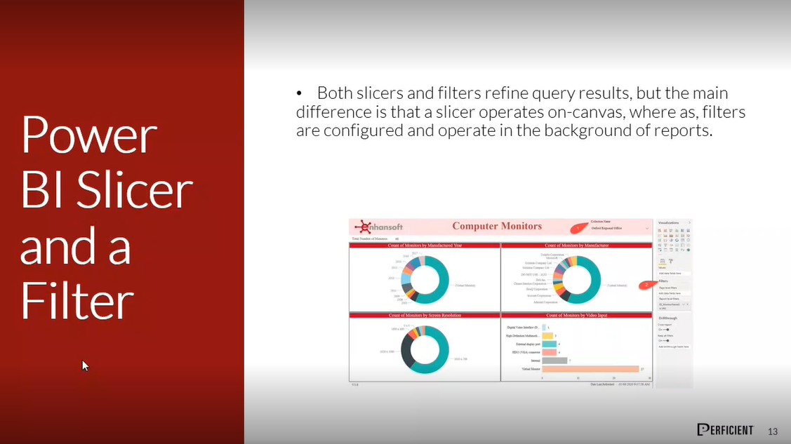

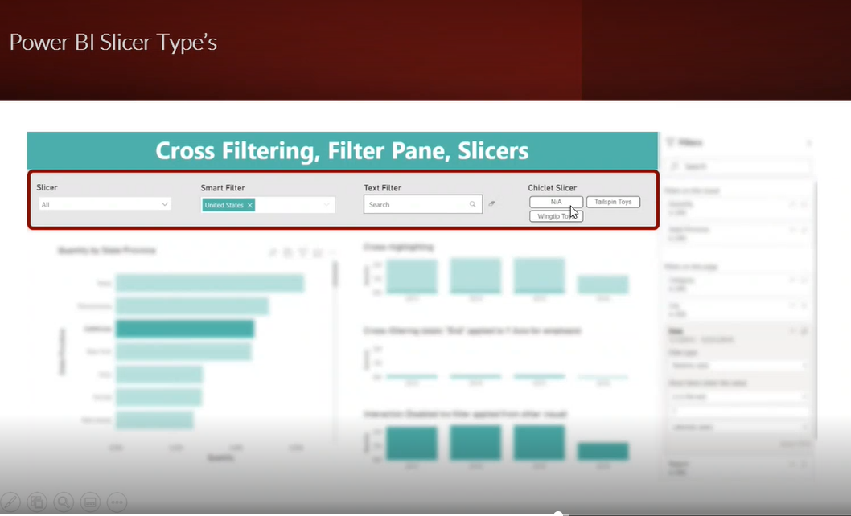

Cross filtering – default

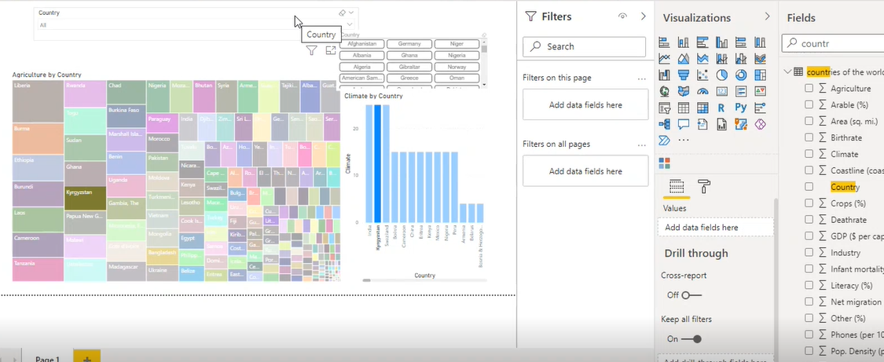

Day3 session:

DAX- Data Analysis Excell

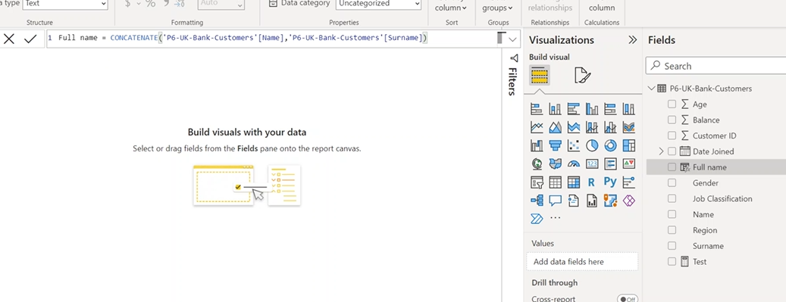

Measure:

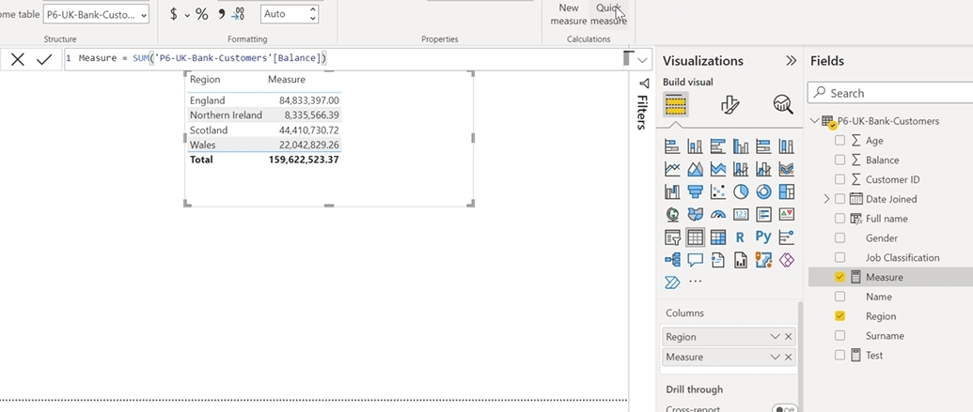

Quick Measure:

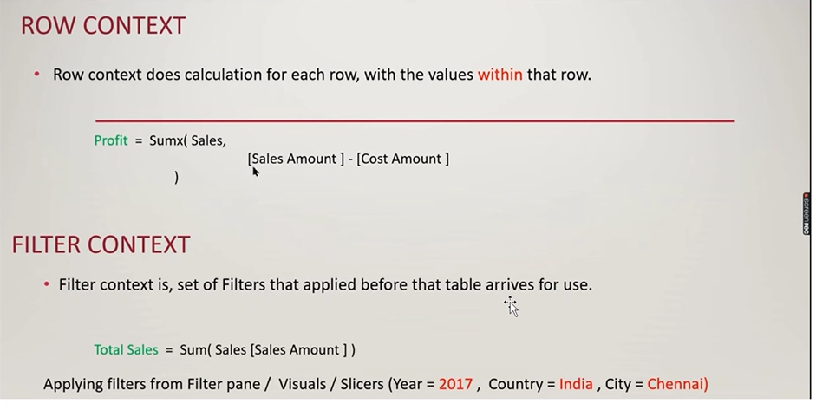

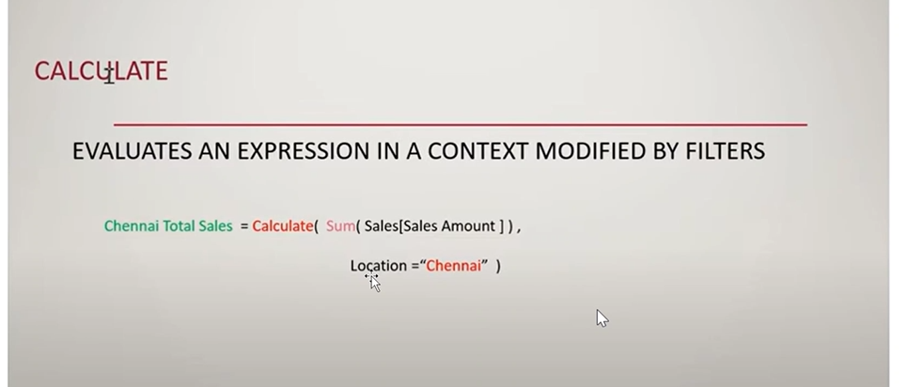

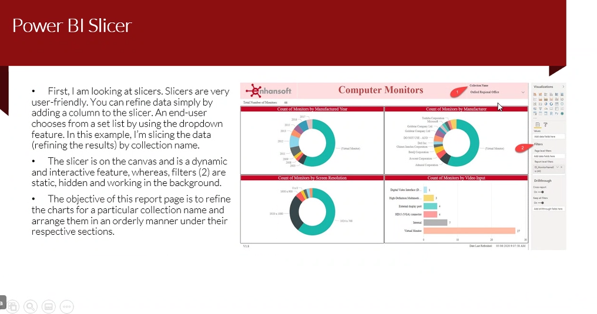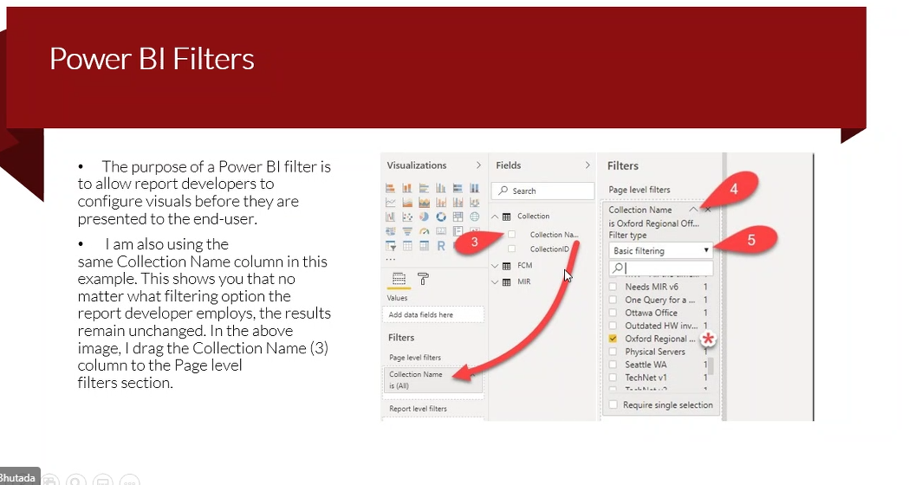

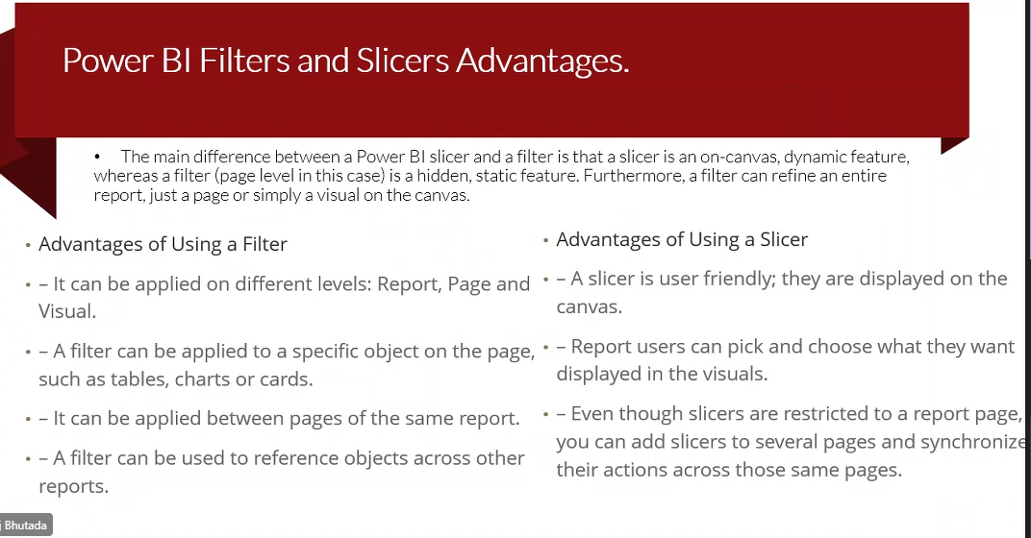

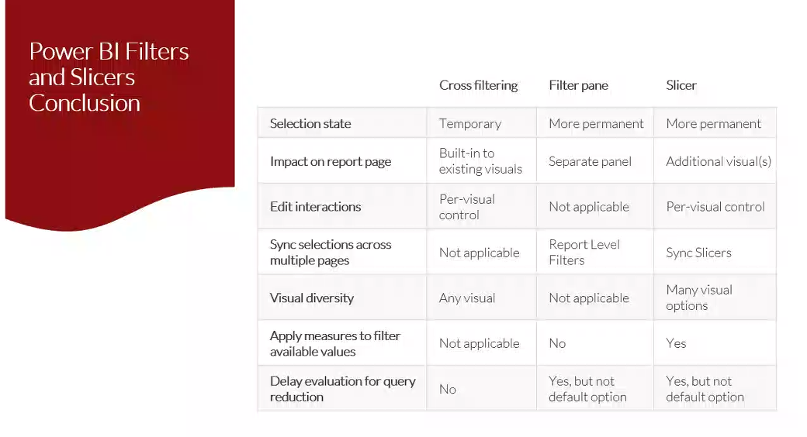

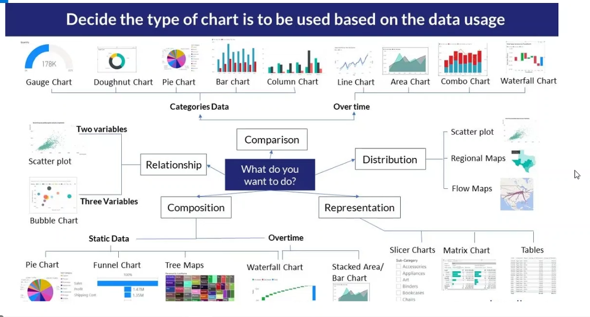

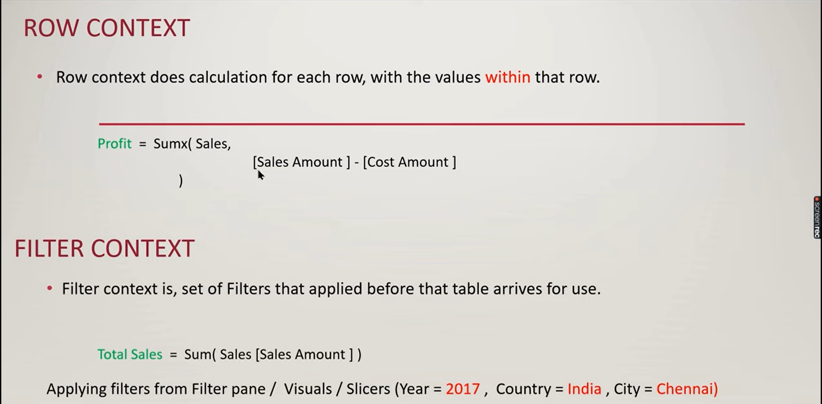

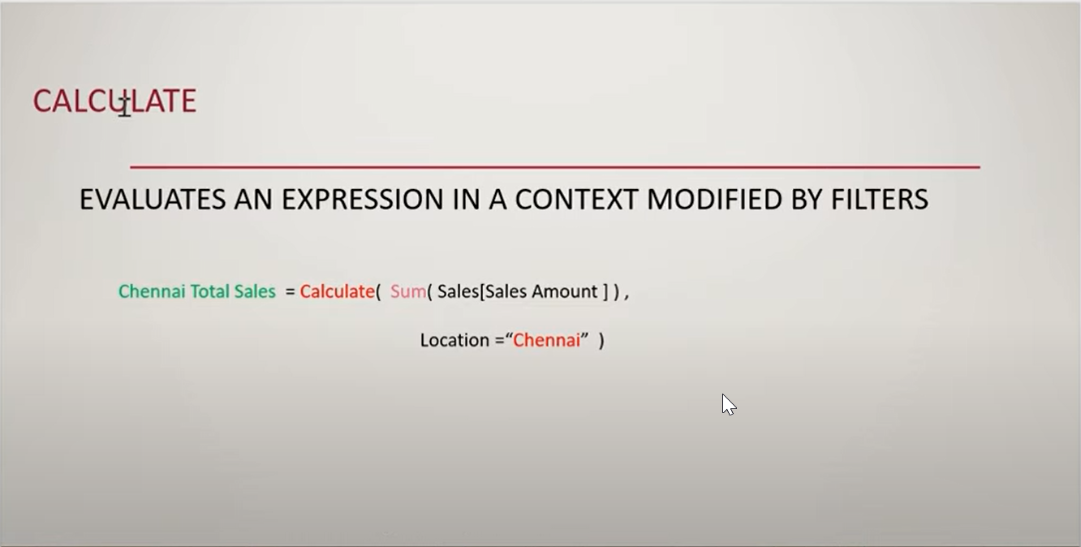

Dax Formatter.

Conquest Customers =CALCULATE (DISTINCTCOUNT ( 'Table'[Customer] ),FILTER (ALLSELECTED ( 'Table'[Customer] ),[**FYTD Measure**] >= 500 && [**PFYTD MEASURE**] =))

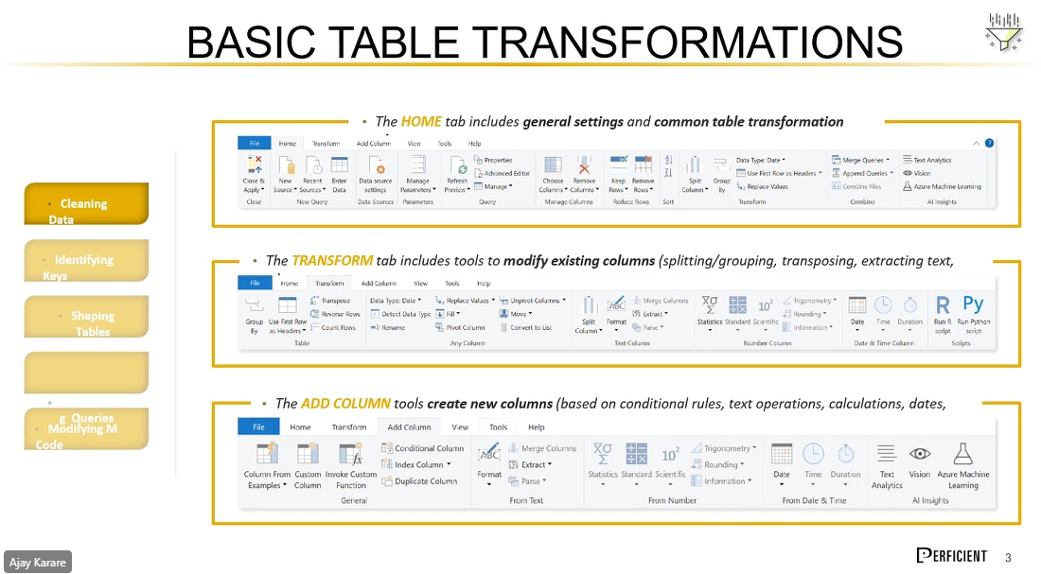

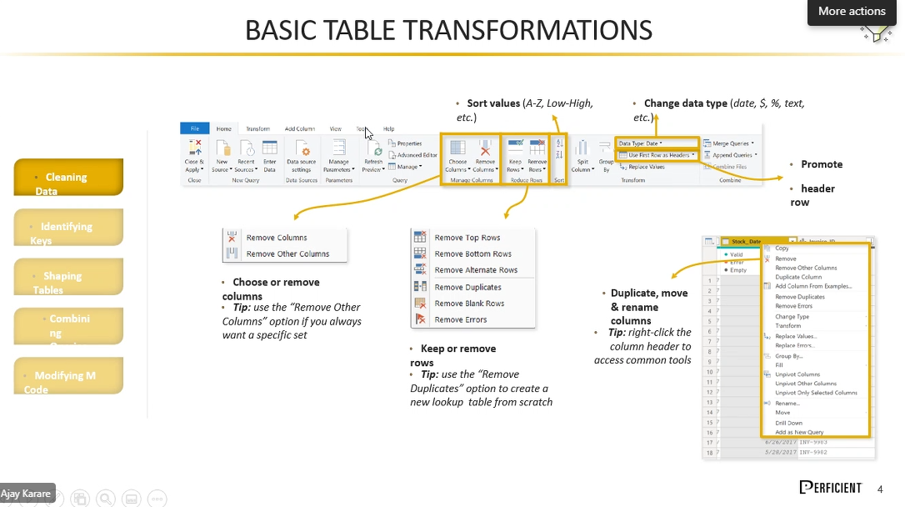

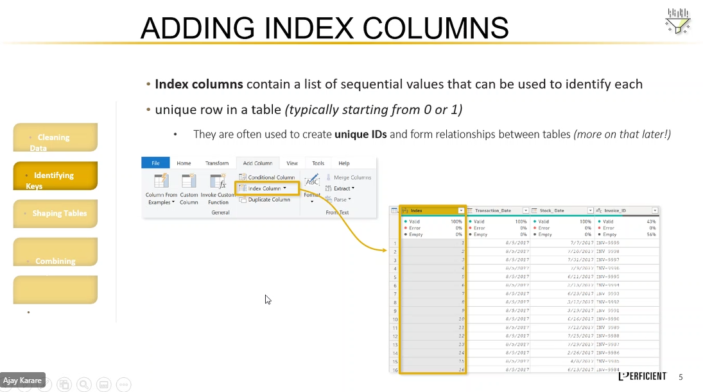

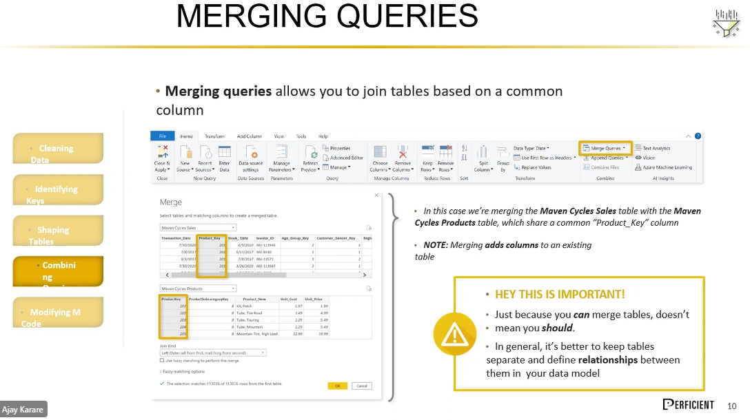

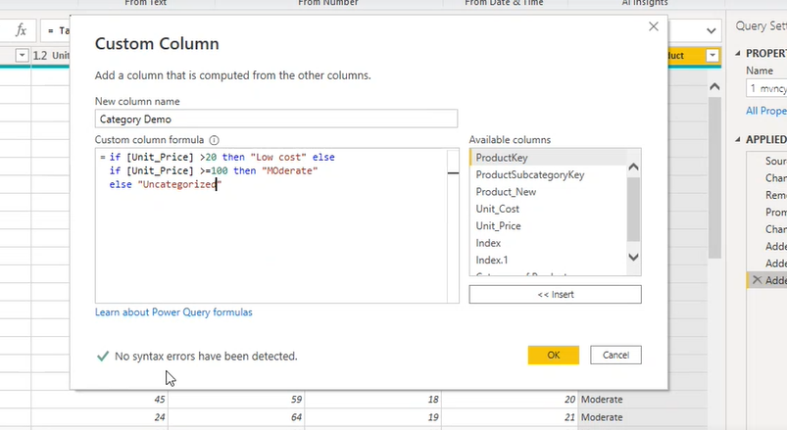

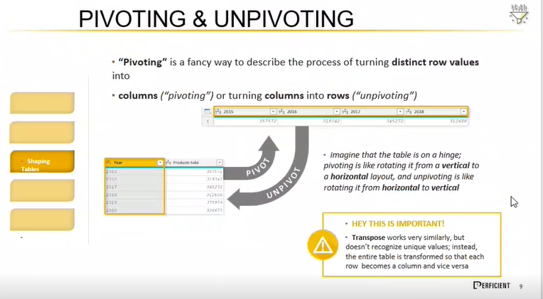

[PowerBI_Bootcamp_May2022 - OneDrive (sharepoint.com)](https://perficient-my.sharepoint.com/personal/syednaseer_ahmed_perficient_com/_layouts/15/onedrive.aspx?id=%2Fpersonal%2Fsyednaseer%5Fahmed%5Fperficient%5Fcom%2FDocuments%2FPowerBI%5FBootcamp%5FMay2022&ga=1)